

DBMS

DOCUMENT BY:
NAME: Prathmesh Vishwakarma
ROLL NUMBER: 26
PRN: 12410438
BATCH: 1

ASSIGNMENT NO.1

CREATE DATABASE university;
USE university;
CREATE TABLE VIT (
id int ,
name varchar(30),
age int ,
subject varchar(30));
INSERT INTO VIT VALUES(1,"CHARUTA",18,"DBMS");
INSERT INTO VIT VALUES
(2,"CHARUTA",19,"PYTHON"),
(3,"RAM",18,"ENGLISH"),
(4,"SHAM",20,"GERMAN"),
(5,"POOJA",19,"ELECTRONICS"),
(6,"KAVAYA ",18,"OPPS"),
(7,"DEV",20,"PYTHON");
SELECT *FROM VIT;
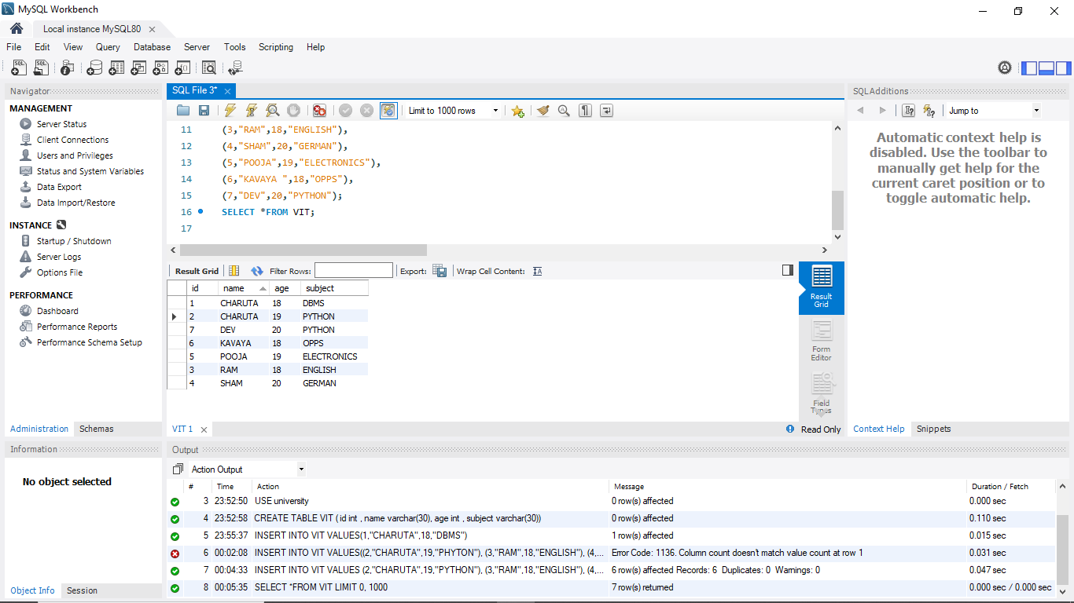
ALTER TABLE VIT ADD COLUMN CONTACT INT;
SELECT *FROM VIT;
ALTER TABLE VIT MODIFY COLUMN CONTACT BIGINT;
INSERT INTO VIT (CONTACT) VALUES (803455612),
(2374902311),(3345668900),(6783444555),(256790556),
(5639055674),(778921107);
SELECT *FROM VIT;
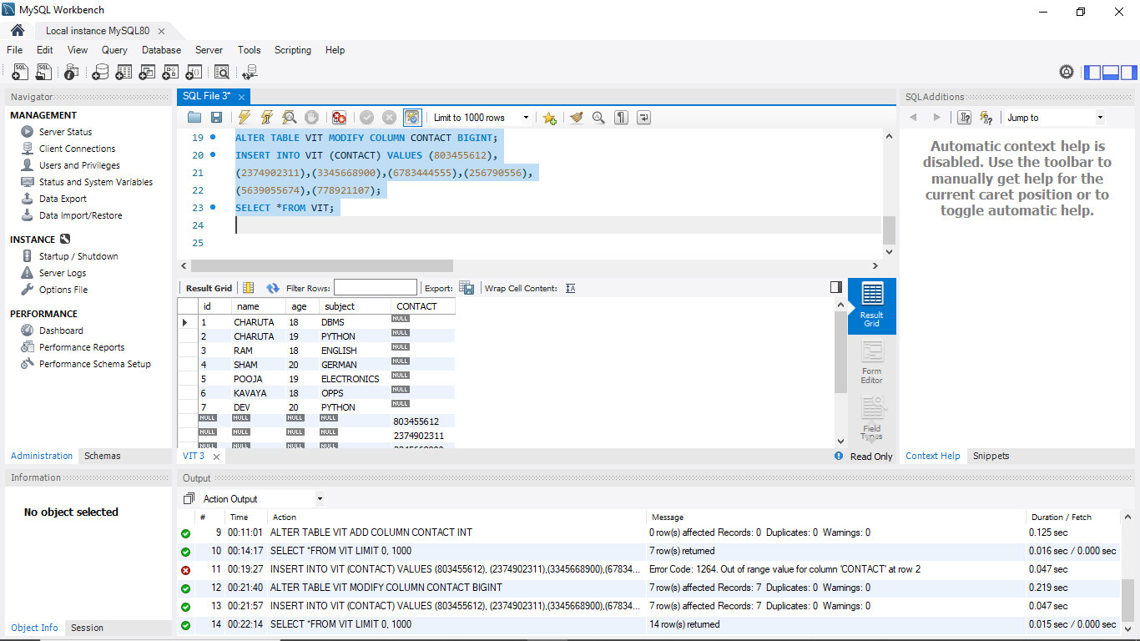
DELETE FROM VIT WHERE name IS NULL AND age IS NULL AND subject IS NULL;
SELECT *FROM VIT;
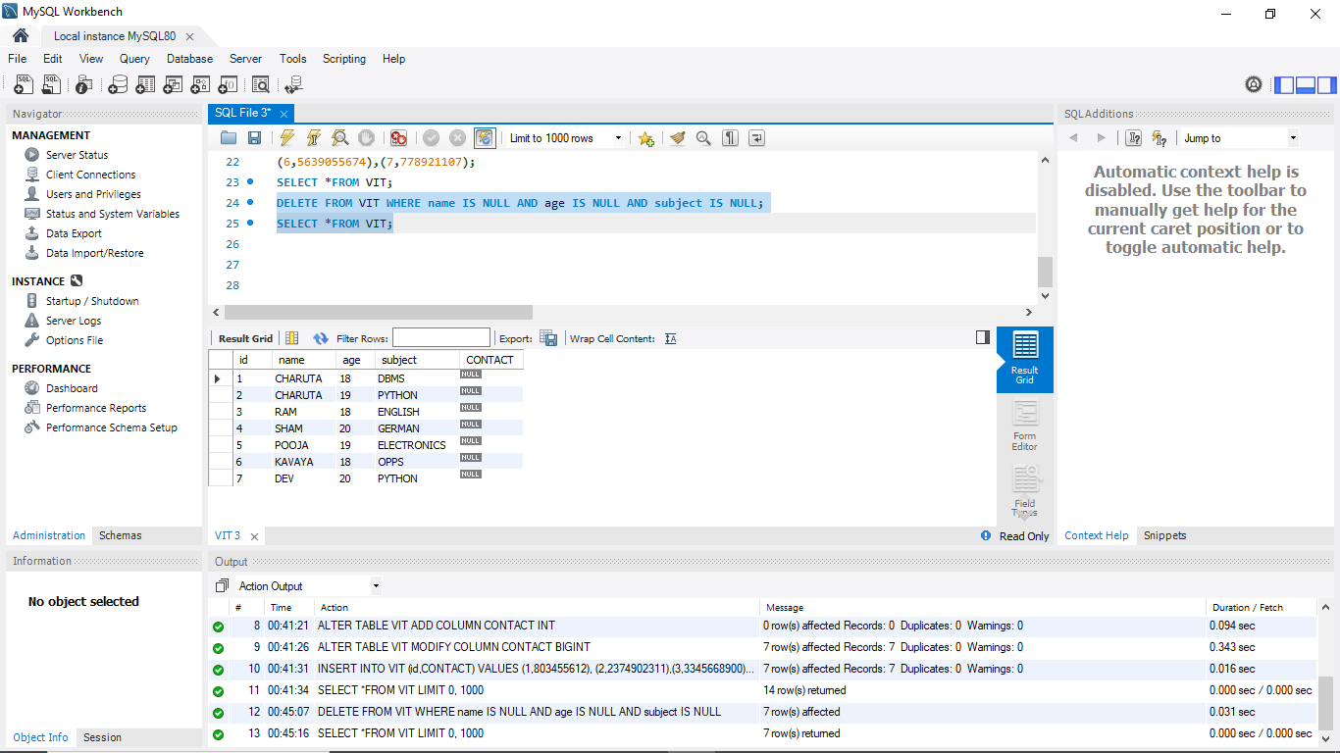
UPDATE VIT SET CONTACT=456733456 WHERE id=1;
UPDATE VIT SET CONTACT=3455678990 WHERE id=2;
UPDATE VIT SET CONTACT=4567211304 WHERE id=6;
UPDATE VIT SET CONTACT=9855324756 WHERE id=4;
UPDATE VIT SET CONTACT=5687990432 WHERE id=3;
UPDATE VIT SET CONTACT=8956344561 WHERE id=5;
UPDATE VIT SET CONTACT=4507330560 WHERE id=7; 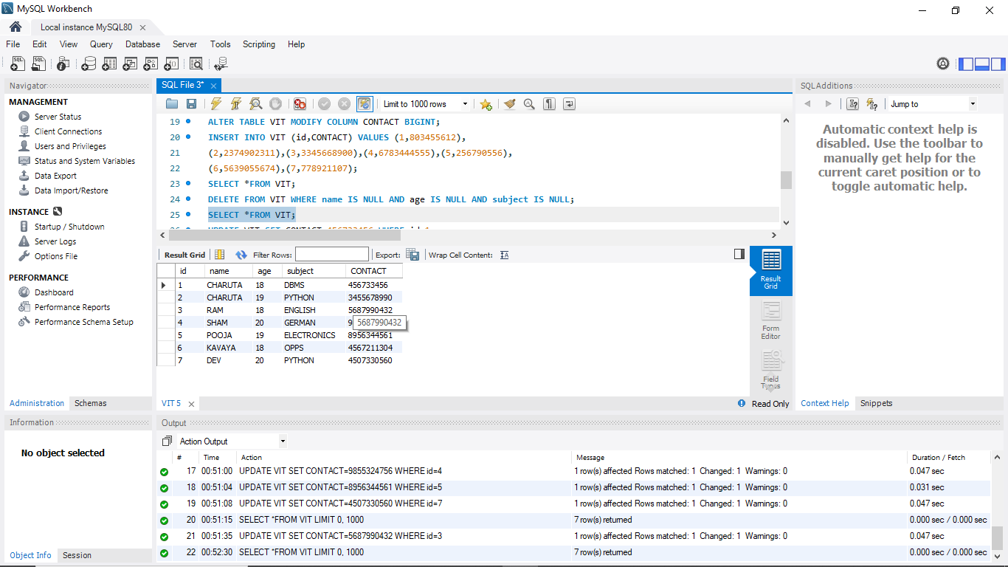 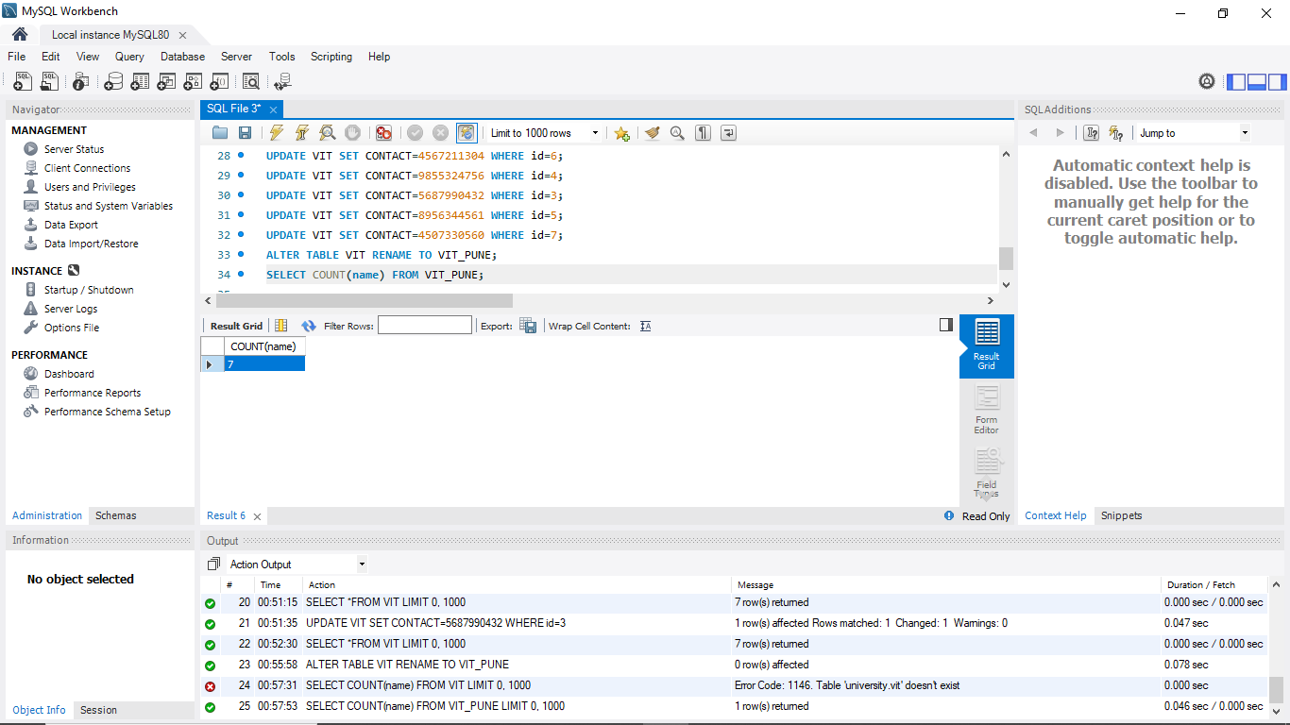

ALTER TABLE VIT RENAME TO VIT_PUNE;
SELECT COUNT(name) FROM VIT_PUNE;
ALTER TABLE VIT_PUNE ADD MARKS INT;
UPDATE VIT_PUNE SET MARKS=46 WHERE id=1;
UPDATE VIT_PUNE SET MARKS=30 WHERE id=2;
UPDATE VIT_PUNE SET MARKS=46 WHERE id=6;
UPDATE VIT_PUNE SET MARKS=98 WHERE id=4;
UPDATE VIT_PUNE SET MARKS=79 WHERE id=3;
UPDATE VIT_PUNE SET MARKS=63 WHERE id=5;
UPDATE VIT_PUNE SET MARKS=45 WHERE id=7; 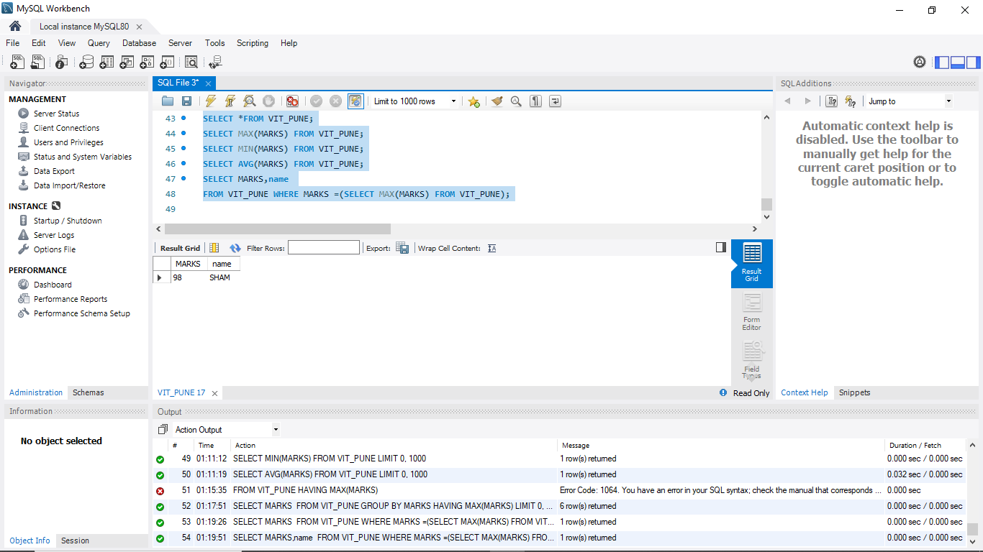
SELECT *FROM VIT_PUNE;
SELECT MAX(MARKS) FROM VIT_PUNE;
SELECT MIN(MARKS) FROM VIT_PUNE;
SELECT AVG(MARKS) FROM VIT_PUNE;
SELECT MARKS,name
FROM VIT_PUNE WHERE MARKS =(SELECT MAX(MARKS) FROM VIT_PUNE);
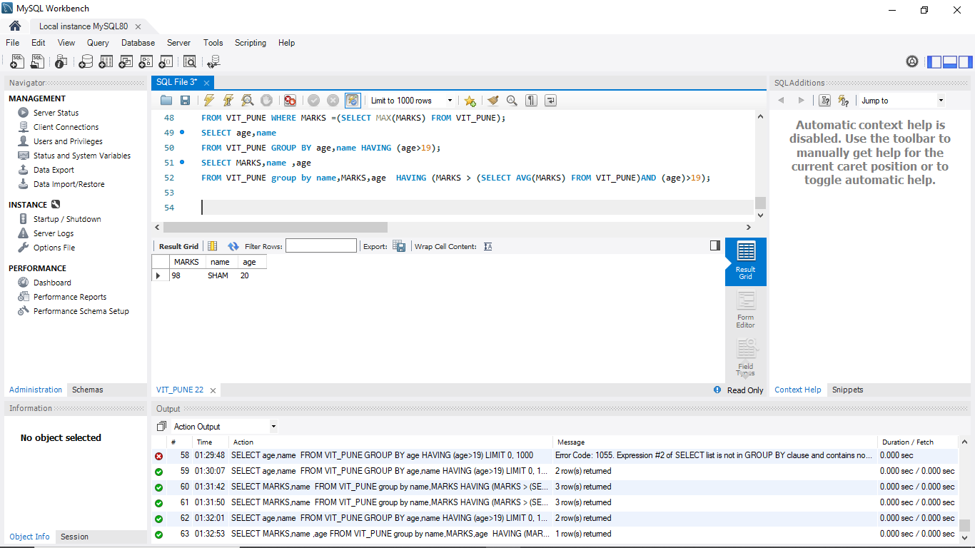 SELECT age,name
FROM VIT_PUNE GROUP BY age,name HAVING (age>19);
SELECT MARKS,name ,age
FROM VIT_PUNE group by name,MARKS,age HAVING (MARKS > (SELECT AVG(MARKS) FROM VIT_PUNE)AND (age)>19);

SELECT MARKS,name ,age
FROM VIT_PUNE group by name,MARKS,age HAVING (MARKS > (SELECT AVG(MARKS) FROM VIT_PUNE)AND (age)>19);
SELECT * FROM VIT_PUNE
order by age asc;
SELECT marks FROM VIT_PUNE
order by age asc;
DELETE FROM VIT_PUNE WHERE SUBJECT="ENGLISH"; 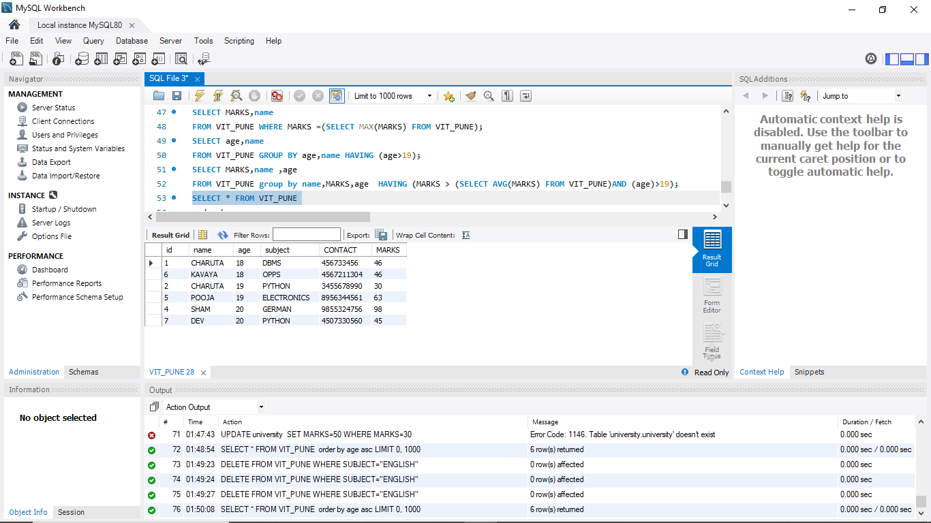

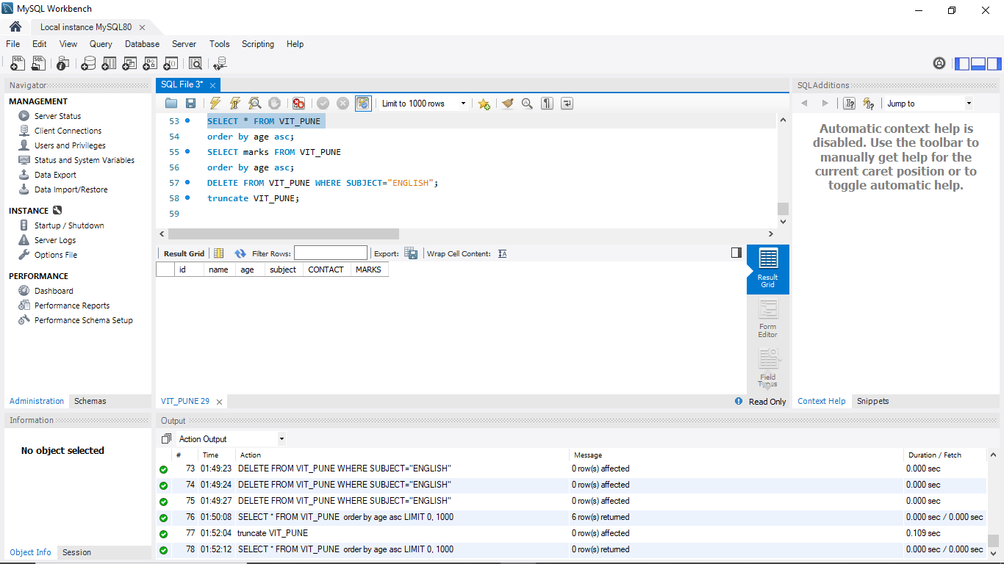 truncate VIT_PUNE;

